

**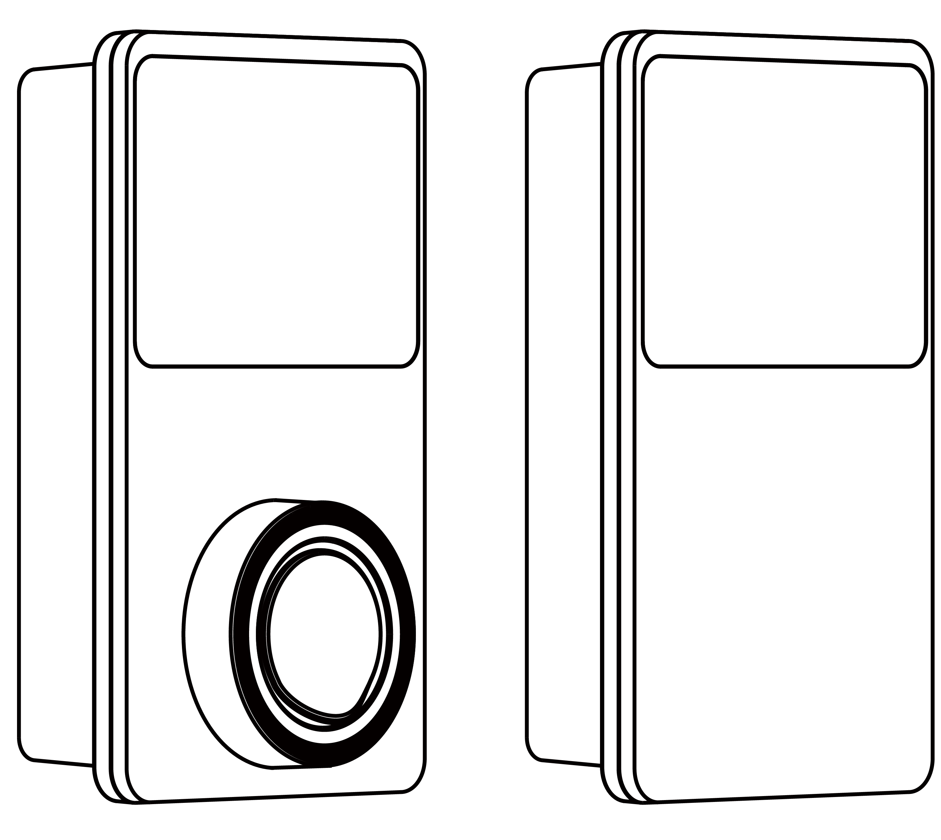**

**User Manual**

**MaxiCharger AC Wallbox**

**Trademarks**

Autel® and MaxiCharger® are trademarks of Autel Intelligent Technology Corp., Ltd., registered in China, the United States and other countries. All other marks are trademarks or registered trademarks of their respective holders.

**Copyright Information**

No part of this manual may be reproduced, stored in a retrieval system or transmitted, in any form or by any means, electronic, mechanical, photocopying, recording, or otherwise without the prior written permission of Autel.

**Disclaimer of Warranties and Limitation of Liabilities**

All information, specifications and illustrations in this manual are based on the latest information available at the time of printing.

Autel reserves the right to make changes at any time without notice. While information of this manual has been carefully checked for accuracy, no guarantee is given for the completeness and correctness of the contents, including but not limited to the product specifications, functions, and illustrations.

Autel will not be liable for any direct, special, incidental, indirect damages or any economic consequential damages (including the loss of profits).

**For Services and Support:**

**Web:** <www.autelenergy.eu>

**Tel:** +49 (0) 89 540299608 (Europe)

**Email:** evsupport.eu@autel.com

**Address**: Landsberger Str. 408/4. OG 81241 Munich, Germany

For technical assistance in all other markets, please contact your local selling agent.

**CONTENTS**

1 Using This Manual 1

1.1 Conventions 1

2 Safety 2

2.1 Safety Messages 2

2.2 Safety Instructions 2

2.3 Disposal Instructions 3

3 General Introduction 4

3.1 Product Overview 5

3.2 Options 7

3.3 Description of the Display 9

3.4 Wiring Diagram for MCB, RCD, and Emergency Stop 13

3.5 Product Model 14

3.6 In the Box 15

3.7 Installation Tools (Not Included) 15

4 Installation 16

4.1 Prepare for Installation 16

4.2 Mechanical Installation 16

4.3 Power Supply Wiring 18

4.4 Connect to the Internet 20

4.5 Finish Installation 21

4.6 Protective Device 22

5 Operation 23

5.1 Energize the Charger 23

5.2 Start Charging 23

5.3 Stop Charging 24

6 Troubleshooting and Service 25

6.1 Troubleshooting Table 25

6.2 Service 27

7 Specifications 28

7.1 General Specifications 28

7.2 Cable Specifications 30

7.3 Supplementary Specifications 30

7.4 Manufacturer and Models 31

7.5 Product Dimensions 32

8 Compliance Information 33

9 Appendix 34

9.1 Fault Codes List 34

1. Using This Manual

This manual describes the installation and use of the MaxiCharger AC Wallbox. Prior to installation, read through this manual to be familiarized with the instructions of this MaxiCharger to ensure a successful installation and smooth operations.

* 1. Conventions

The following conventions are used.

* + 1. Bold Text

Bold text is used to highlight selectable items such as buttons and menu options.

* + 1. Notes and Important Messages

**Notes**

A **NOTE** provides helpful information such as additional explanations, tips, and comments.

**Important**

**IMPORTANT** indicates a situation which, if not avoided, may result in damage to the test equipment or vehicle.

* + 1. Hyperlink

Hyperlinks or links that take you to other related articles, procedures, and illustrations are available in electronic documents.

* + 1. Illustrations

Illustrations used in this manual are only examples; the actual product(s) or screens may vary.

* + 1. Revision History

|  |  |  |
| --- | --- | --- |
| **Version** | **Date** | **Descriptions** |
| V1 | 2022.05.10 | Initial version |
| V2 | 2022.10.27 | Merged user manual and installation manual |
| V2.1 | 2023.02.10 | Complete manual overhaul |

1. Safety

For your own safety and the safety of others, and to prevent damage to the charging station and vehicles upon which it is used, it is important that the safety instructions presented throughout this manual be read and understood by all persons operating or coming into contact with the charging station.

1. 1. Safety Messages

Safety messages are provided to help prevent personal injury and equipment damage. All safety messages are introduced by a single word indicating the hazard level.

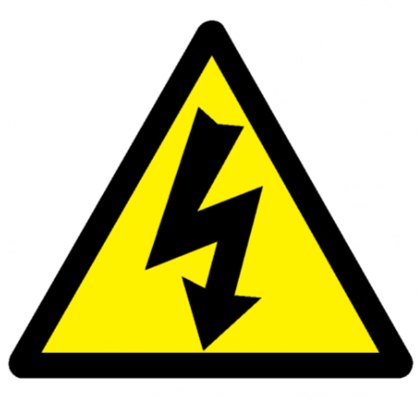**DANGER**

Indicates an imminently hazardous situation with a high risk level which, if the danger is not avoided, will cause death or serious injury.

**WARNING**

Indicates a potentially hazardous situation with moderate risk level which, if the warning is not obeyed, can cause death or serious injury.

**CAUTION**

Indicates a potentially hazardous situation with a medium risk level which, if the caution is not obeyed, may cause minor or moderate injury or damage to the equipment.

* 1. Safety Instructions

The safety messages herein cover situations Autel is aware of. Autel cannot know, evaluate or advise you as to all of the possible hazards. You must be certain that any condition or service procedure encountered does not jeopardize your personal safety.

**SAFETY WARNINGS**

* Read and follow all warnings and instructions before installing and operating the MaxiCharger.
* Only a qualified electrician is allowed to install, service, repair and relocate the MaxiCharger.
* The user must not attempt to service or repair the MaxiCharger as it does not contain user-serviceable parts.
* Switch off input power before installing the MaxiCharger. Keep the power off until it is fully installed and secure.
* Do not use explosive or readily flammable substances near the MaxiCharger.
* Do not use the MaxiCharger if the charging cable is frayed, broken or otherwise damaged, or fails to operate.
* Do not use the MaxiCharger if the enclosure or the EV connector is frayed, broken or otherwise damaged, or fails to operate.
* In the event of danger and/or an accident, a qualified electrician must immediately disconnect the electrical supply from the MaxiCharger.
* Refer to the vehicle user manual to check if the vehicle releases hazardous or explosive gases when charging.
* Follow the instructions given in the vehicle user manual before choosing the charging location of the MaxiCharger.
* Do not direct powerful water jets toward the MaxiCharger.
* Do not operate the MaxiCharger with wet hands.
* Do not put the charging handle into any liquid.
* Do not install or open the MaxiCharger in wet environment (such as rain or heavy fog).
* Ensure that the charging cable is positioned so that it will not be stepped on, tripped over, driven over or otherwise subjected to excessive force or damage. Where applicable, ensure that the charging cable is correctly stowed when not in use and that the charging handle does not touch the ground.
* Keep the charging handle away from heat sources, dirt or water.
* Use this MaxiCharger to charge compatible electric vehicles only. Refer to the technical specifications in this manual. Refer to the vehicle manual to check if the vehicle is compatible.
* Only use the MaxiCharger under the specified operating conditions in this manual.
* Local regulations may be applicable and may vary depending on your region/country of use. The qualified electrician must always ensure that the MaxiCharger is installed in accordance with the local regulations.

**CAUTION**

* Ensure that the charging cable is not damaged or tangled prior to use.
* Do not insert fingers into the charging port.
* Do not leave objects inside the charging port.
* Keep and use (electro) magnetic devices at a safe distance from the MaxiCharger.
  1. Disposal Instructions

Handling waste incorrectly can have a negative effect on the environment and human health due to potential hazardous substances. Discard the charging station correctly can facilitate the reuse and recycling the materials and environmental protection.

* Obey the local rules when discarding parts, packaging materials or the charging station.
* Discard electrical and electronic equipment separately in compliance with the WEEE-2012/19/EU Directive on waste of electrical and electronic equipment.
* Do not mix or dispose the charging station with the household waste.

1. General Introduction

The MaxiCharger AC wallbox is designed to charge an electric vehicle (hereinafter called EV). Our chargers provide you with safe, reliable, fast, and smart charging solutions.

This manual will instruct you how to install and use this charger.

**Intended Use**

This MaxiCharger is intended for the AC charging of EVs. It is intended for both indoor and outdoor use.

* Residential
* Commercial
* Workplace
* Vehicle Workshop

**DANGER**

* **If you use the charging station in any way other than described in this manual or other related documents, possible death, injury and damage to property can occur.**
* **Use the charging station only as intended.**

**NOTE**

* This manual is for cable, socket, and shutter models. The illustrations in this manual use the socket version as an example.
* The images and illustrations depicted in this manual may differ slightly from the actual ones.

1. 1. Product Overview

**MaxiCharger AC Wallbox**

**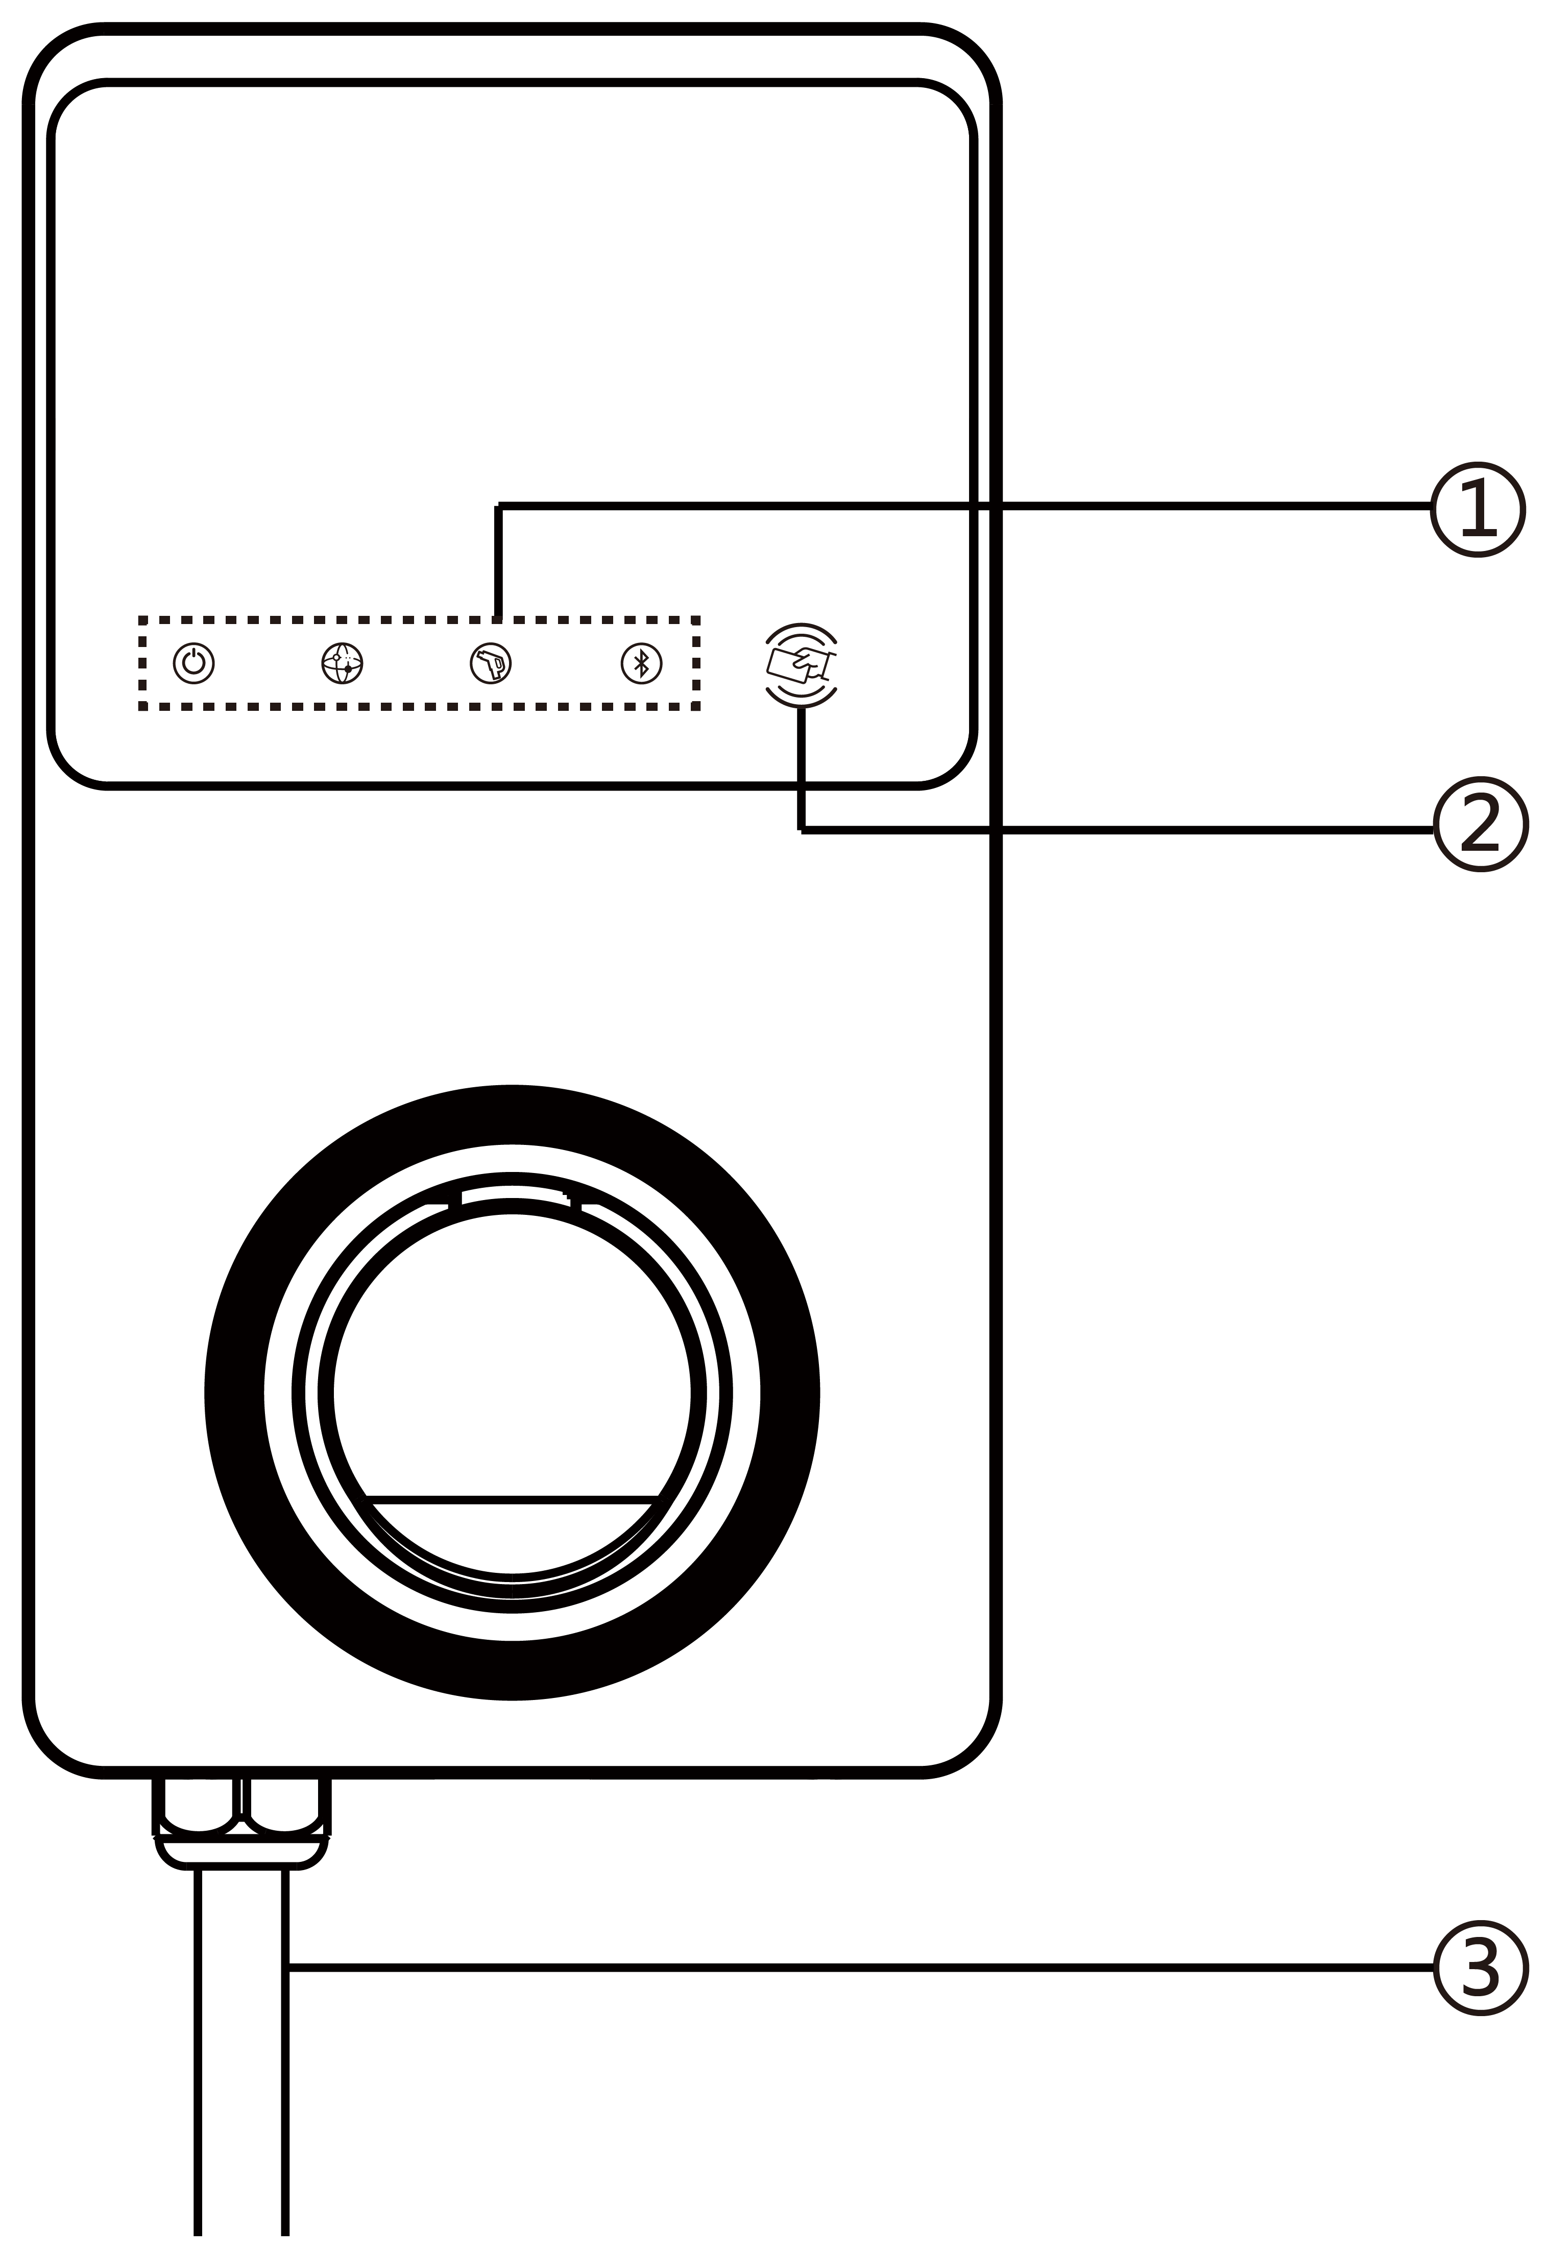**

1. LED Indicators (from left to right):

* Power LED
* Internet Connection LED
* Charging LED
* Bluetooth Connection LED

1. RFID Reader
2. AC Input Cable
3. RJ45 Ethernet Port
4. 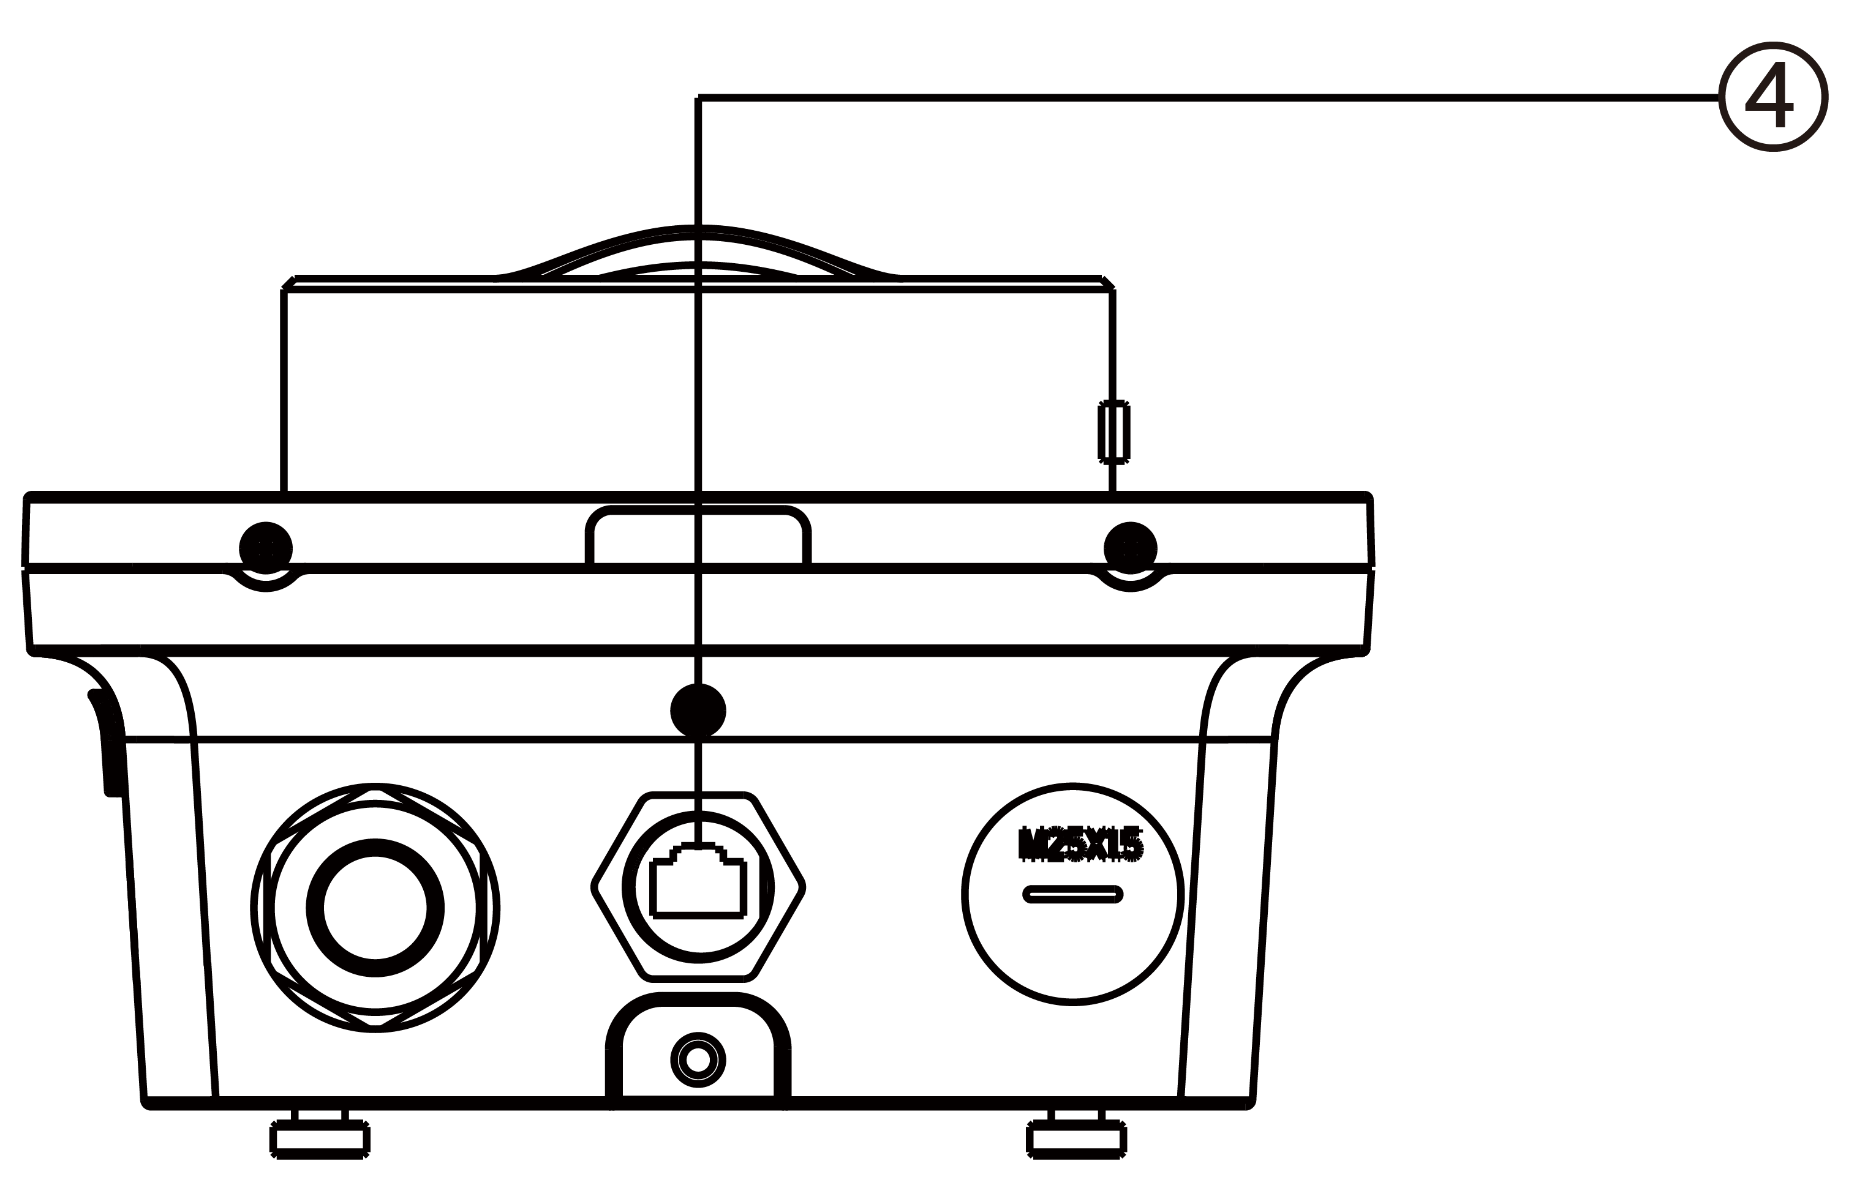Mounting Screws
5. Rear Entry Signal Conduit Plug
6. Rear Entry Power Conduit Plug
7. Product Label

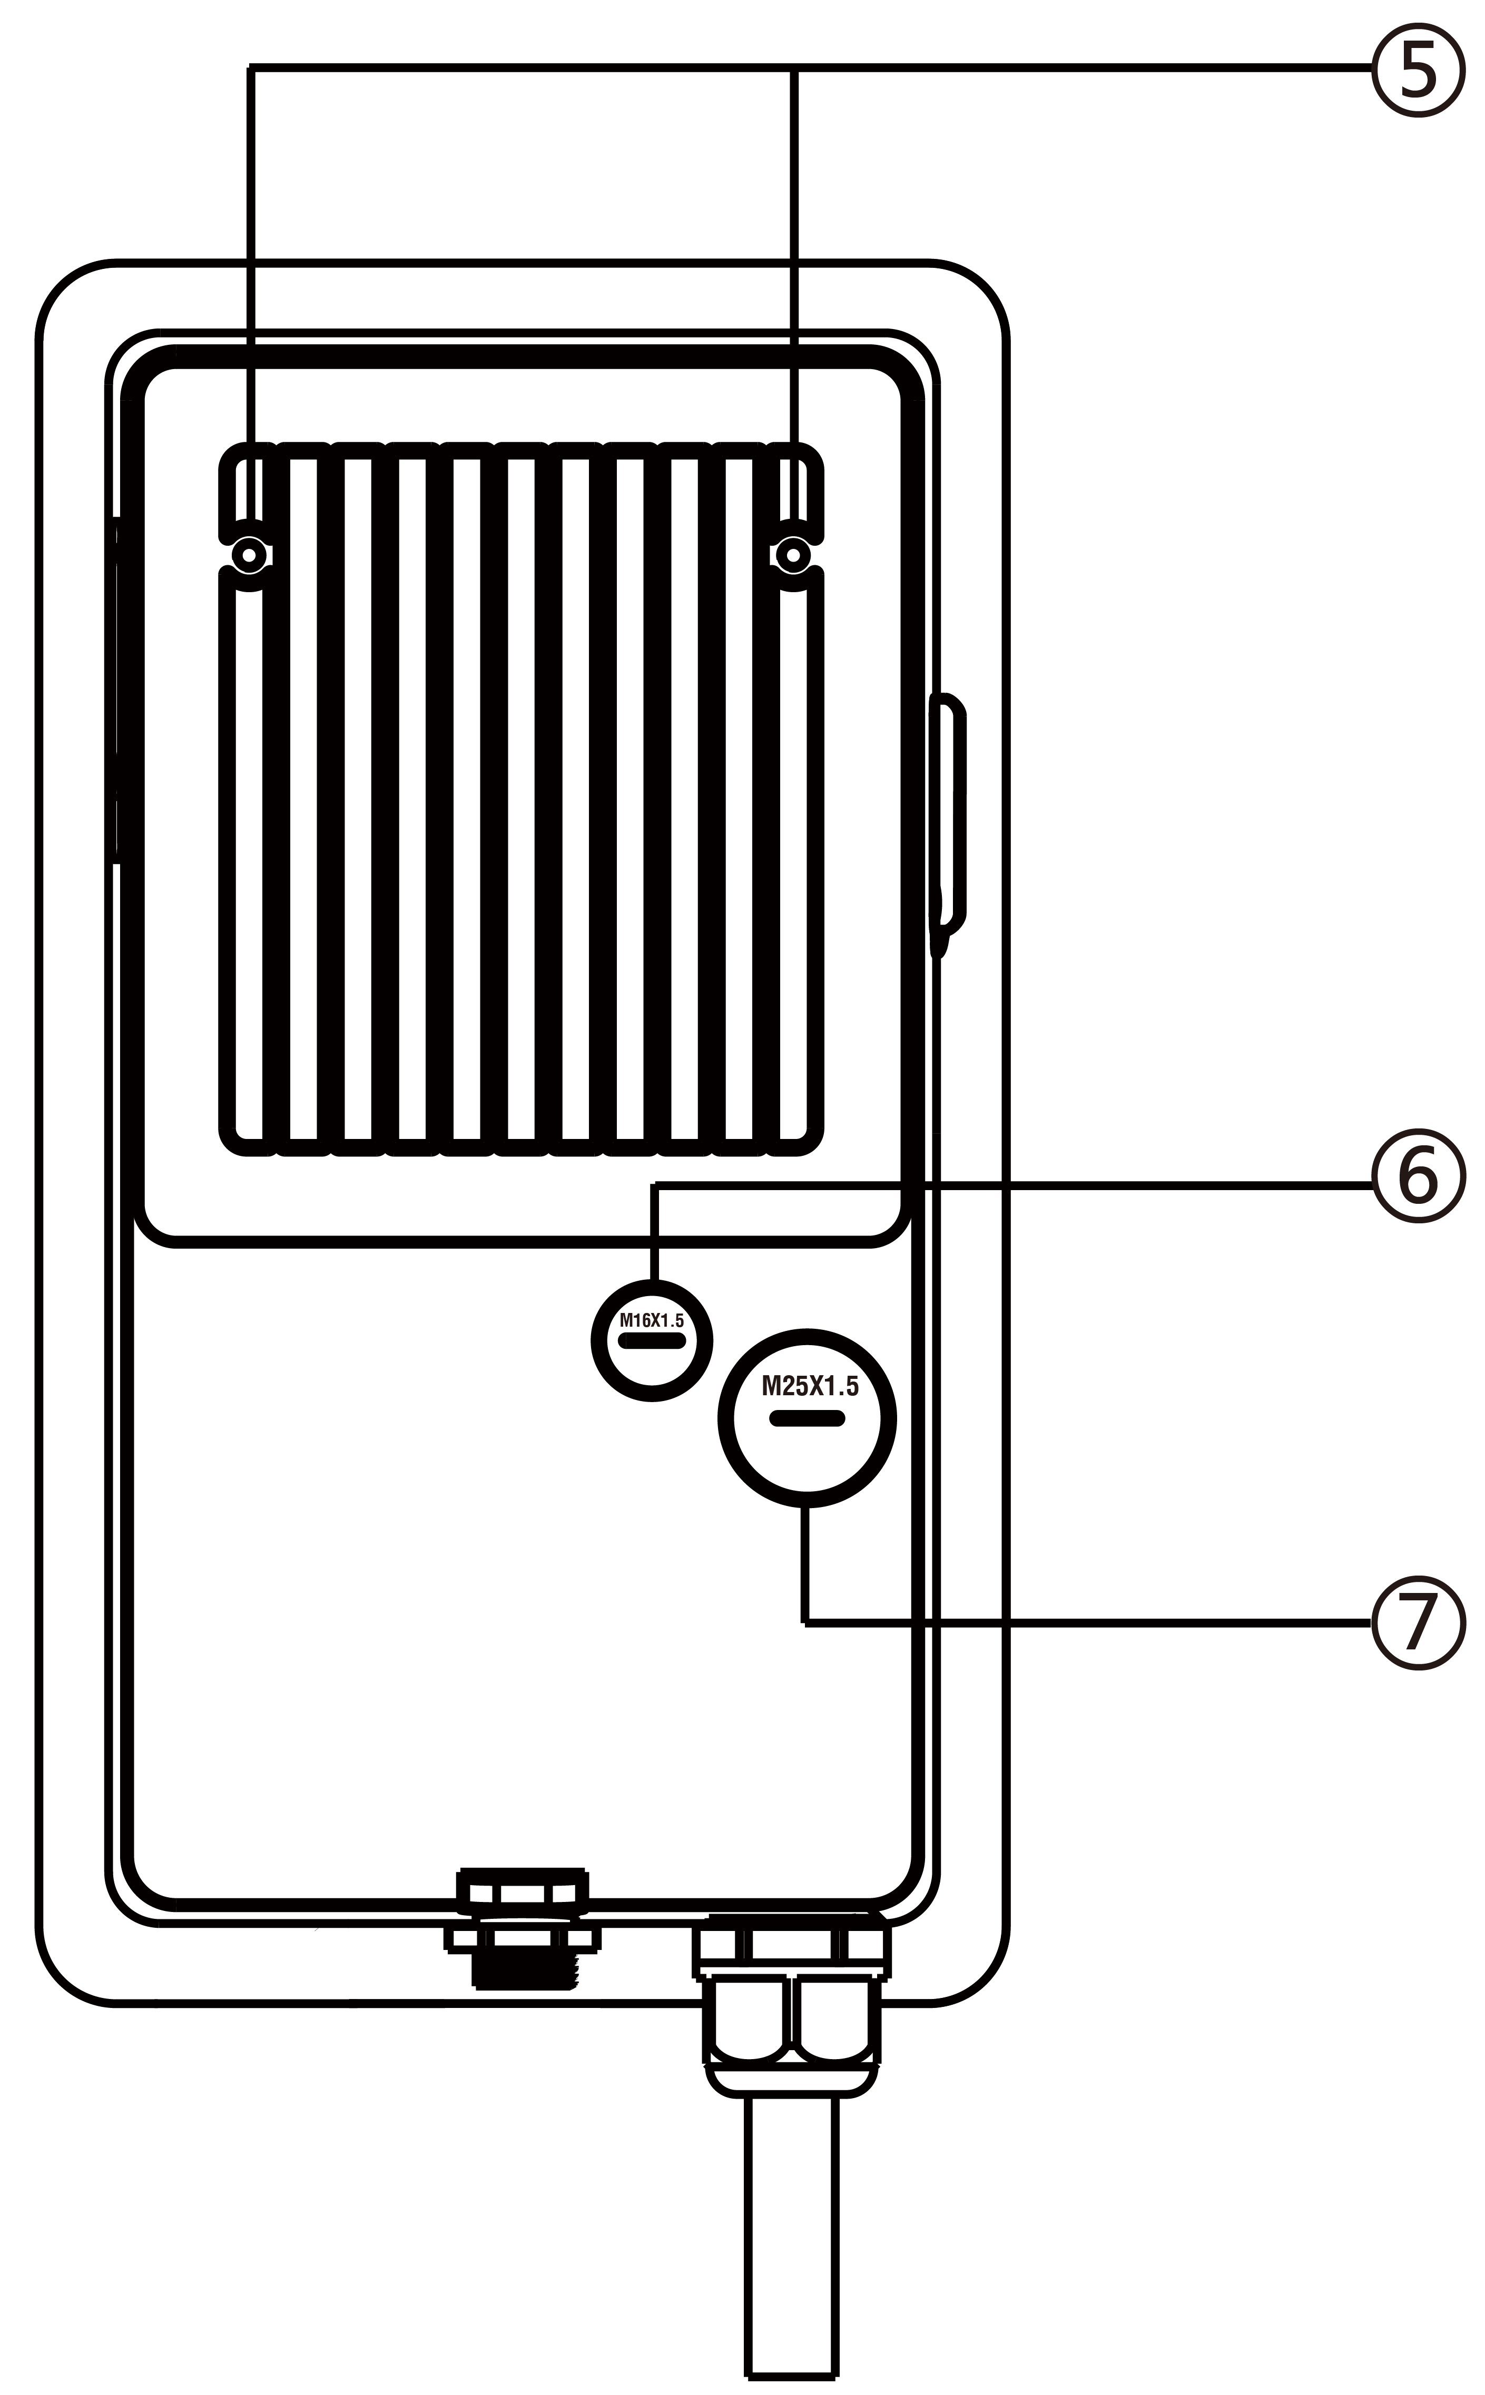

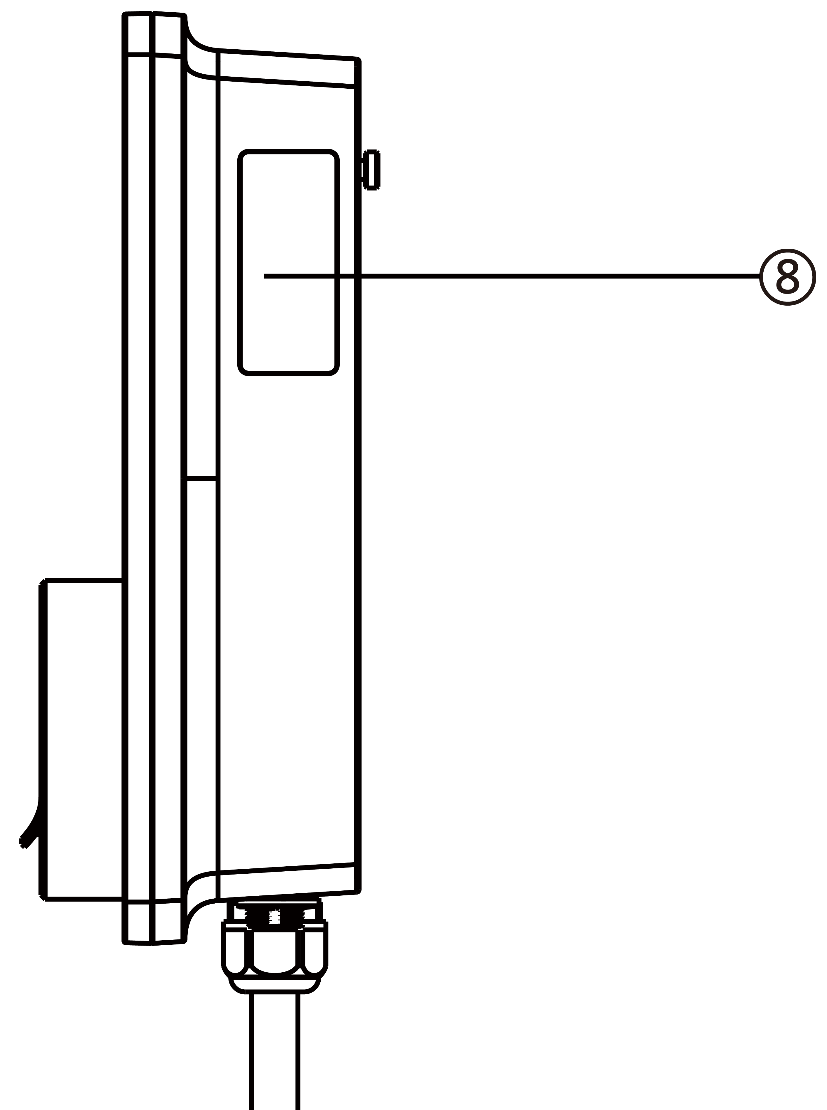

**LED Description**

|  |  |
| --- | --- |
| **LED** | **Description** |
| **Power LED** | * **Solid Green:** The charger is on. * **Off:** The charger is off. * **Flashing Yellow:** Datais being transmittedand/orfirmware is upgrading. * **Solid Yellow:** Firmware upgrade has failed. * **Solid Blue:** Data transmission has failed; will turn solid green in five seconds (see above). |
| **Internet Connection LED** | * **Solid Green:** The charger is connected to the Internet. * **Off:** The charger is not connected to the Internet. * **Flashing Green:** The charger has joined the DLB (Dynamic Load Balancing) network. |
| **Charging LED** | * **Solid Blue:** An EV is connected. * **Flashing Blue:** A schedule is active. * **Flashing Cyan:** The charger is reserved. * **Flashing Green:** An EV is charging. * **Solid Yellow:** A recoverable error has occurred or it is temporarily disabled by the server. * **Solid Green:** A charge session has ended. * **Off:** No EV connected. * **Solid Red:** An irrecoverable error has occurred. (Please contact support.) |
| **Bluetooth**  **Connection LED** | * **Flashing Green:** The charger is connected to a mobile device via Bluetooth. * **Flashing Blue:** The charger is connected to VCI (Vehicle Communication Interface) via Bluetooth. * **Flashing Cyan:** The charger is connected to a mobile device and a VCI device simultaneously via Bluetooth. * **Off:** The charger is not connected via Bluetooth. |

* 1. Options

|  |  |
| --- | --- |
| **Display**   1. Ambient Light Sensor — detects ambient brightness 2. Display 3. Energy Pulse Output (Infrared Ray) | **C:\Users\A20476\Desktop\5寸欧标快引导图-5_画板 1.png** |

|  |  |
| --- | --- |
| **Cable Model**   1. Charging Handle Safety Lock — **Press** **to release charging handle from its cradle** 2. Charging Handle, Type 2 3. Cradle 4. EV Charge Cable   NOTE  Drape the EV charge cable over the top of the MaxiCharger and dock the connector in its holster when not in use. See the figure on the right.  The maximum length of the EV charge cable is 7.5 meters. | C:\Users\A20476\Desktop\5寸欧标快引导图-6_画板 1.png  **With Holster**  C:\Users\A20476\Desktop\5寸欧标快引导图-7_画板 1.png  **Without Holster** |

|  |  |
| --- | --- |
| **Socket/Shutter Model**   1. Socket/Shutter, Type 2 | C:\Users\A20476\Desktop\5寸欧标快引导图-8_画板 1.png |

|  |  |
| --- | --- |
| 1. **SIM Card Socket**   (Available on chargers with 4G function.) | C:\Users\A20476\Desktop\5寸欧标快引导图-9_画板 1.png |

* 1. Description of the Display

**IMPORTANT**

This section is only applicable to chargers with a display.

**Function Buttons**

|  |  |
| --- | --- |
| **Button** | **Description** |
| **Cost Details** | Tap to view the charging cost. |
| **Language** | Tap to choose your language for the charger. |
| **Stop** | Tap to stop a charge session. |
| **OK** | Tap to confirm the information on the screen. |
| **Back** | Tap to return to the previous screen. |

* + 1. Boot Screen

****

The display shows the Boot screen while the charger starting up.

* + 1. Standby/Authorization Screen

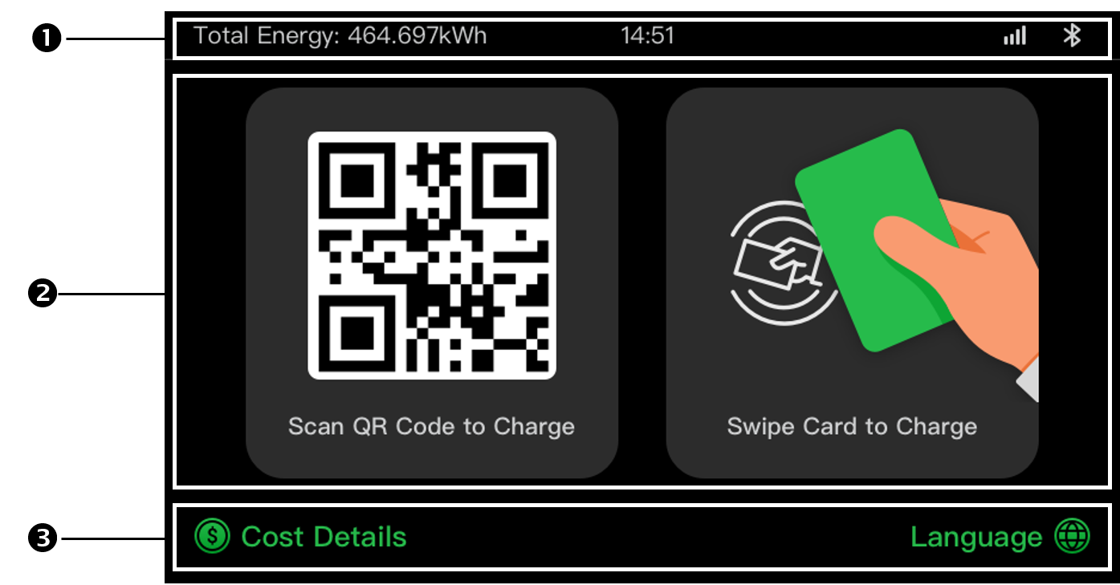

1. Top screen — displays total delivered energy, time, signal strength, and Bluetooth connection
2. Middle screen — provides two authorization methods: QR code or RFID card
3. Bottom screen — tap to view the charging costs and adjust the language

The display shows the Standby/Authorization screen when the charger is in idle status, indicating that the charger is ready for use. When this screen appears, choose an authorization method (QR code or RFID card) to start a charge session.

* + 1. Preparing to Charge Screen

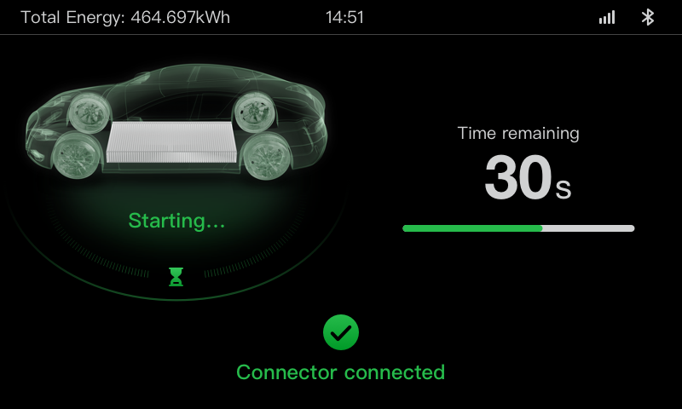

* + 1. Charging Screen

The Charging screen appears during the charge session.

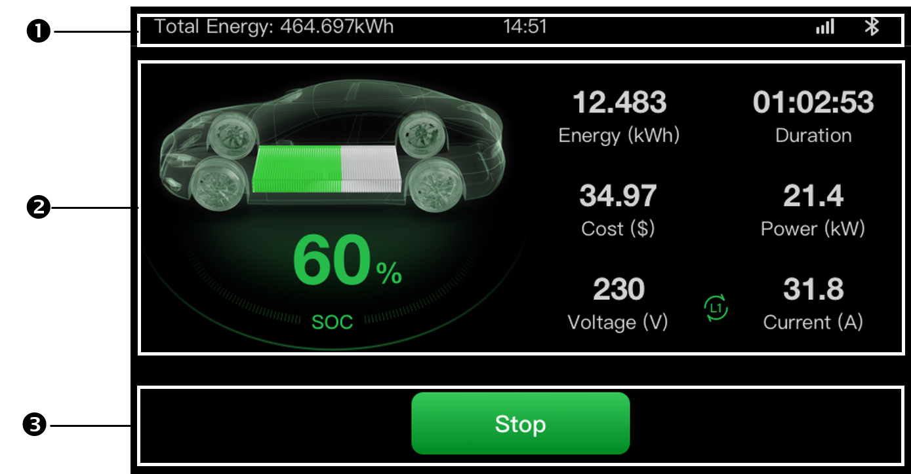

1. Top screen
2. Main Charging screen — shows the real-time charging progress, the SOC value, and other charging information including energy, duration, current cost, power, voltage, as well as current per phase.
3. Stop button — tap to stop the charge session
   * 1. Transaction Details Screen

When the charge session ends, the Transaction Details screen will appear.

Tap the **OK** button to confirm your transaction details.

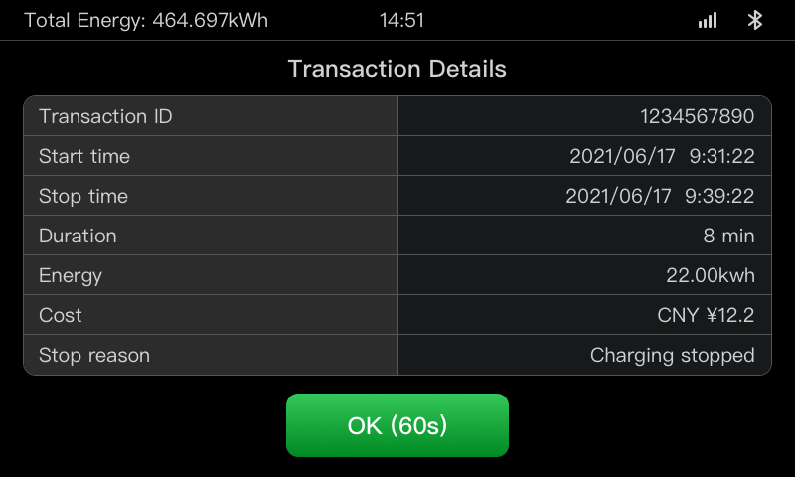

* + 1. Device Information Screen

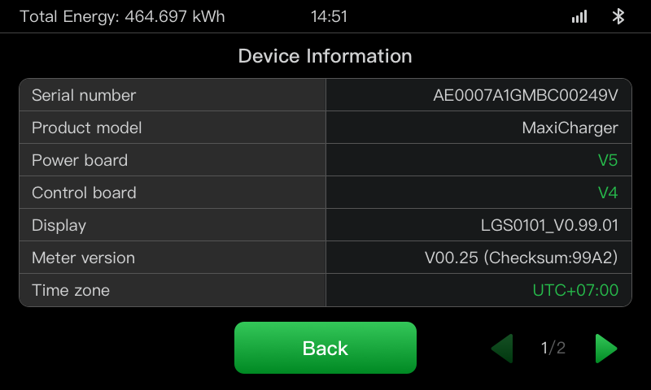

The actual Device Information screen may differ.

* + 1. Error Screen

The display shows different error messages depending on the error type.

The charger fails to start a charge session:

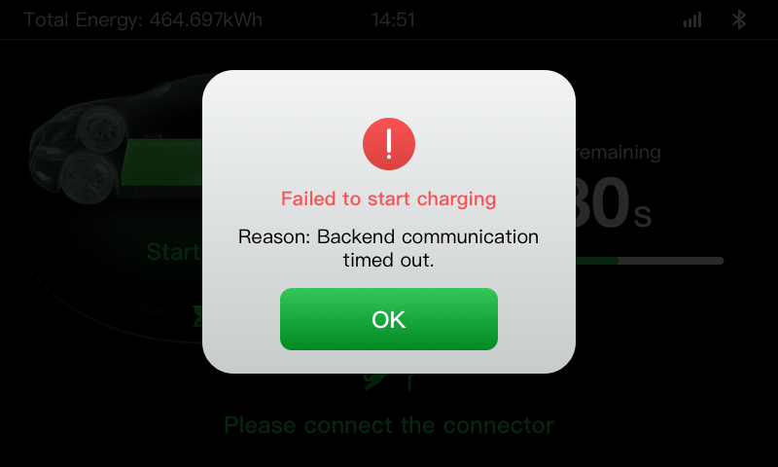

Tap the **OK** button to confirm the message.

An error has occurred with the charger. Contact Autel support.

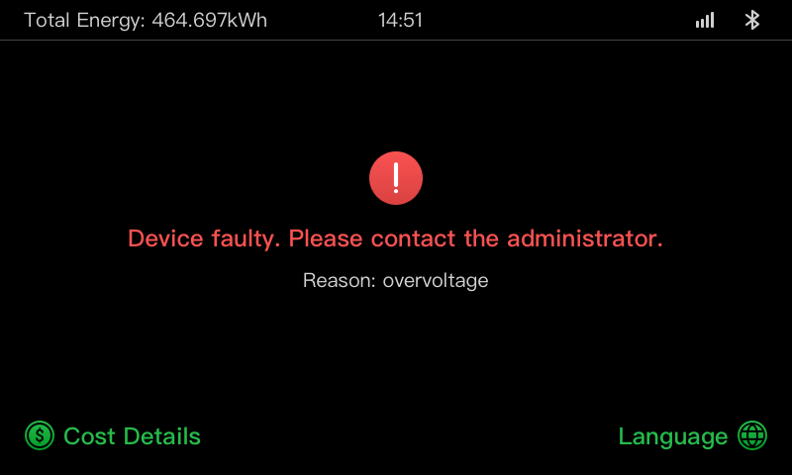

* 1. Wiring Diagram for MCB, RCD, and Emergency Stop
     1. For 7.4 kW model



* + 1. For 11/22 kW Model

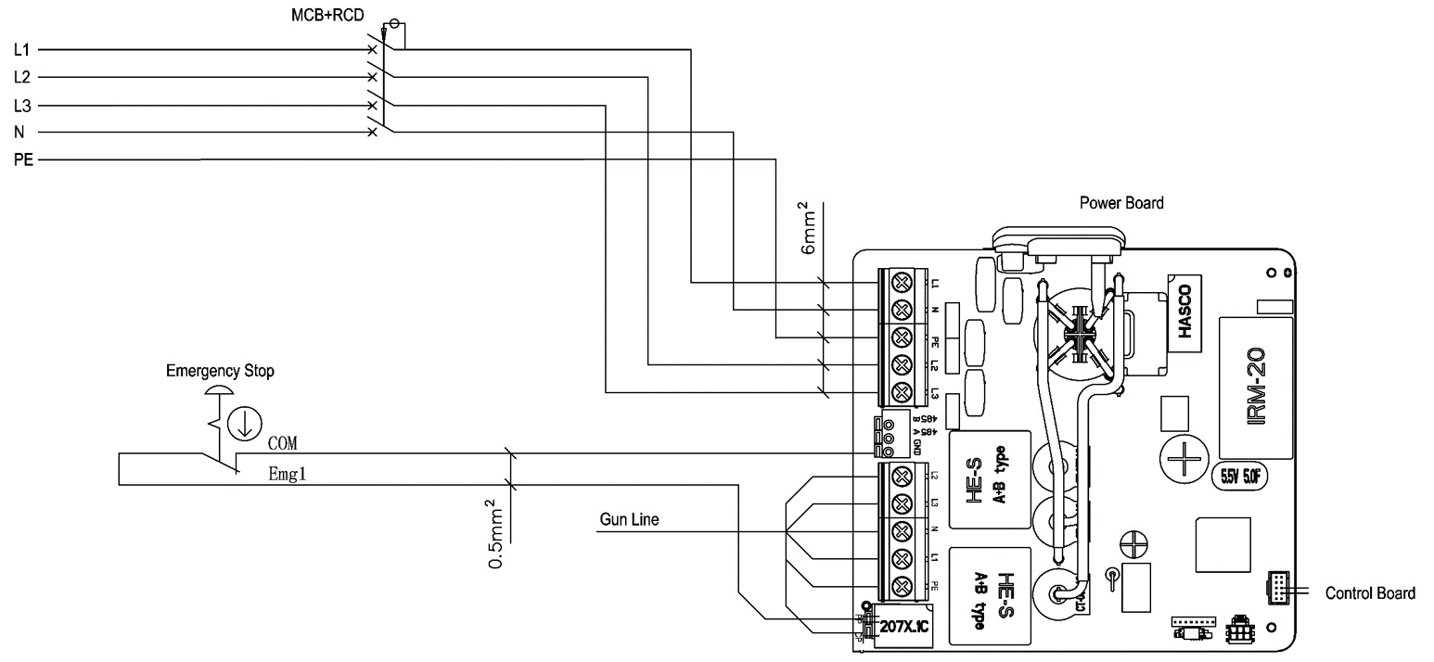

* 1. Product Model

The MaxiCharger AC Wallbox model is a code that consists of seven parts:

Maxi U W - XX - YY - L - M - ZZ

|  |  |  |  |
| --- | --- | --- | --- |
| **Code Part** | **Description** | **Value** | **Meaning of Value** |
| **U** | Basic model designation | EU AC | EU AC series |
| EU1 AC | EU1 AC series |
| **W** | Power | W7 | 7.4 kW |
| W11 | 11 kW |
| W22 | 22 kW |
| **XX** | Vehicle connection method | BC3 | vehicle connector with 3-meter cable without holder |
| BC5 | vehicle connector with 5-meter cable without holder |
| BC7 | vehicle connector with 7.5-meter cable without holder |
| C3 | vehicle connector with 3-meter cable |
| C5 | vehicle connector with 5-meter cable |
| C7 | vehicle connector with 7.5-meter cable |
| S | Socket-outlet (Not for 11kW models) |
| H | shutter-outlet (Not for 11kW models) |
| **YY** | Wireless function | 4G | 4G function embedded |
| Blank | Standard type |
| **L** | LCD panel function |  |  |
| **M** | MID function |  |  |
| **ZZ** | Color | DG | Dark grey |
| WH | White |
| RG | Rose gold |
| SV | Silver |
| B | Black |

* 1. In the Box

|  |  |  |  |  |  |
| --- | --- | --- | --- | --- | --- |
| **MaxiCharger**  1 PC | C:\Users\A20476\Desktop\欧标5寸-外观图_画板 1.png | **Wall Dock**  1 PC | D:\主要文件\主要项目\欧标充电桩\欧标交流桩用户手册\欧标交流桩导图\欧标壁挂板_画板 1.png | **Cable Sealing Ring (M25)**  1 PC | C:\Users\A20476\Desktop\图7_画板 1.png |
| **Screw**  **(M6 x 50)**  2 PCS | C:\Users\A20476\Desktop\图3_画板 1.png | **Screw**  **(M5 x 12)**  1 PC | C:\Users\A20476\Desktop\图4_画板 1.png | **Cable Sealing Ring (M16)**  1 PC | C:\Users\A20476\Desktop\图8_画板 1.png |
| **Wall Plug**  **(8 mm)**  2 PCS | C:\Users\A20476\Desktop\图5_画板 1.png | **Charge Card**  2 PCS | C:\Users\A20476\Desktop\图6_画板 1.png | **Waterproof Ethernet Cable Gland**  1 PC | C:\Users\A20476\Desktop\图9_画板 1.png |
| **Screw (M3 x 8)**  **(For spare use)**  3 PCS | D:\主要文件\主要项目\欧标充电桩\欧标交流桩用户手册\欧标交流桩导图\欧标交流新增备用螺钉M3X8_画板 1.png | **Screwdriver**  **(type T10)**  1 PC | C:\Users\A20476\Desktop\图10_画板 1.png | **Screwdriver**  **(type T25)**  1 PC | C:\Users\A20476\Desktop\图11_画板 1.png |

* 1. Installation Tools (Not Included)

Ensure the following tools are readily available prior to installation.

|  |  |  |  |  |  |
| --- | --- | --- | --- | --- | --- |
| **Spirit Level** | C:\Users\A20476\Desktop\欧标交流-水平尺_画板 1.png | **Power Drill** | C:\Users\A20476\Desktop\欧标交流-电钻_画板 1.png | **Tape Measure** | C:\Users\A20476\Desktop\欧标交流-卷尺_画板 1.png |
| **Screwdriver (PH2)** | C:\Users\A20476\Desktop\欧标交流-螺丝刀_画板 1.png | **Pencil** | C:\Users\A20476\Desktop\欧标交流-铅笔_画板 1.png | **Drill Bit (8 mm)** | C:\Users\A20476\Desktop\欧标交流-钻头_画板 1.png |
| **Wire Stripper** | C:\Users\A20476\Desktop\欧标交流-剥线钳_画板 1.png | **Crimping Tool** | C:\Users\A20476\Desktop\欧标交流-压线钳_画板 1_画板 1.png |  |  |

1. Installation
   1. Prepare for Installation
      1. Preliminary Requirements

* All required permits have been acquired in accordance with the local regulations.
* The AC input cable is available.
* There is **no voltage** on the AC input cable throughout the installation procedure.
  + 1. Unpack the Charger

1. Open the box.
2. Remove the charger from the box.
3. Remove all the packaging material from the charger.
4. Ensure that all the parts are delivered according to the order.
5. Inspect the charger and the parts for damage. If you find damage or the parts are not consistent with the order, contact your local dealer.
   * 1. Prepare for Installation

* Install the charger on a flat and vertical surface capable of supporting its weight (e.g. a finished brick or concrete wall, a pedestal, etc.). The maximum weight of a charger is about 6 kg (13 lbs.).
* Install the charger in a location that allows the charge cable to remain within its bending tolerance.
* The recommended installation height is between 850 and 1150 mm. The minimum outdoor height is 600 mm and that of indoor is 450 mm.
* Position the charger in a location where it is not vulnerable to being damaged.

* 1. Mechanical Installation

|  |  |
| --- | --- |
| **STEP 1**   1. Place the wall dock against the wall and level it using a spirit level. 2. Mark the two lower mounting holes (**A**) with a pencil and drill two 8 mm holes. 3. Insert the two 8 mm wall plugs (**B**) into the holes. | C:\Users\A20476\Desktop\Deta快引导图-1_画板 1.png |

|  |  |
| --- | --- |
| **STEP 2**   1. Attach the wall dock to the mounting location by inserting two M6 x 50 screws (**C**) into the lower mounting holes. 2. Tighten the two M6 x 50 screws using the PH2 screwdriver (**D**, not included in the package). | **C:\Users\A20476\Desktop\Deta快引导图-2_画板 1.png** |

|  |  |
| --- | --- |
| **STEP 3**  Attach the charger to the wall dock by inserting the two protruding screws (**E**) on the back of the charger into the two upper mounting holes (**F**). Slide the charger downwards to engage the screws. | C:\Users\A20476\Desktop\Deta快引导图-3_画板 1.png |

|  |  |
| --- | --- |
| **STEP 4**  Insert and tighten the included M5 x 12 screw (**G**) into the hole at the bottom of the charger to secure the charger using the T25 Torx screwdriver. | C:\Users\A20476\Desktop\Deta快引导图-4_画板 1.png |

* 1. Power Supply Wiring

**IMPORTANT**

* Consult the local electrical codes for the correct wire size, based on the environment, the conductor type, and the rating of the charger.
* Ensure that all the screws are tightened to the correct torque after the wiring is completed, and that there are no loosen screws at the terminal blocks.
* Ensure there is no copper wire or debris left inside of the charger before switching on the electrical power to the charger.

|  |  |
| --- | --- |
| **STEP 1**   1. Remove the two screws (**I**) at the bottom of the charger with the T10 Torx screwdriver. Then remove the faceplate from the middle of the clasp (**H**). **Set them aside.** | **C:\Users\A20476\Desktop\P-2_画板 1.png** |

|  |  |
| --- | --- |
| 1. Unscrew the five screws (**J**) to remove the maintenance cover (**K**). **Set them aside.** | C:\Users\A20476\Desktop\Deta清单导图_画板 1.png |

|  |  |
| --- | --- |
| **Step 2**  **Single-phase Wiring：**   1. Strip the wires to 12 mm. 2. Loosen the lower-left cable gland, insert the AC input cable through the inlet hole, and pre-fix the cable gland. 3. Loosen the screws at the terminal block. 4. Insert the cable connector into the terminal block. 5. Connect the following wires as specified:  * L1 (Brown) * Earth (PE, green/yellow striped) * Neutral (N, blue)  1. Tighten the screws to 2 N·m and fix the cable gland. | C:\Users\A20476\AppData\Roaming\eSpace_Desktop\UserData\a20476_E35832B92FD67CD7CA1F35DED037857F\ReceiveFile\接线图1.jpg |

|  |  |
| --- | --- |
| **Three-phase Wiring：**   1. Strip the wires to 12 mm. 2. Loosen the lower-left cable gland, insert the AC input cable through the inlet hole, and pre-fix the cable gland. 3. Loosen the screws at the terminal block. 4. Insert the cable connector into the terminal block. 5. Connect the following wires as specified:  * L1 (Brown) * Earth (PE, green/yellow striped) * Neutral (N, blue) * L2 (Black) * L3 (Grey)  1. Tighten the screws to 2 N·m and fix the cable gland. | C:\Users\A20476\AppData\Roaming\eSpace_Desktop\UserData\a20476_E35832B92FD67CD7CA1F35DED037857F\ReceiveFile\接线图.jpg |

* 1. Connect to the Internet

The charger can be connected to the Internet by Ethernet connection, Wi-Fi or a SIM card.

|  |  |
| --- | --- |
| **Via the Ethernet Cable**  **Step 1**  Connect the waterproof Ethernet cable gland to the Ethernet cable:   1. Put the Ethernet cable with RJ45 plug (**a**) through the nut (**b**) and the waterproof cap (**d**) (leave some space between them). 2. Connect the sealing ring (**c**) via its opening to the Ethernet cable and insert it into the waterproof cap. 3. Screw the nut into the waterproof cap and make sure they are securely fastened. | C:\Users\A20476\Desktop\Deta快引导图-8_画板 1.png |

|  |  |
| --- | --- |
| **Step 2**  Put the RJ45 plug of the Ethernet cable into the RJ45 port (**H**) at the bottom of the charger. | C:\Users\A20476\Desktop\Deta快引导图-7_画板 1.png |

|  |  |
| --- | --- |
| **Via the SIM Card**   1. Remove the M3 x 10 screw using the T10 screwdriver to open the SIM card cover. 2. Use an appropriate tool to press the tiny button next to the SIM card tray (**M**) and release the card tray. 3. Insert the SIM card into the tray. Ensure it is inserted correctly. 4. Reinstall the SIM card cover. | **C:\Users\A20476\Desktop\Deta快引导图-9_画板 1.png** |

* 1. Finish Installation
     1. Reinstall the Covers

1. Reinstall the inner cover by tightening the five screws to the right torque.
2. Reinstall the maintenance cover by tightening the two screws at the bottom of the charger.
   * 1. Distribution Box Wiring

Procedures above complete the power supply wiring to the charging station. In order to complete the power supply wiring to the distribution box, connect the wires as specified on the terminal block.

If the charger has the 485 communications cables and you do not need them, coil them with electrical tape respectively. See diagrams below for single-phase and three-phase wiring.

**Distribution Box Wiring for Single-phase:**

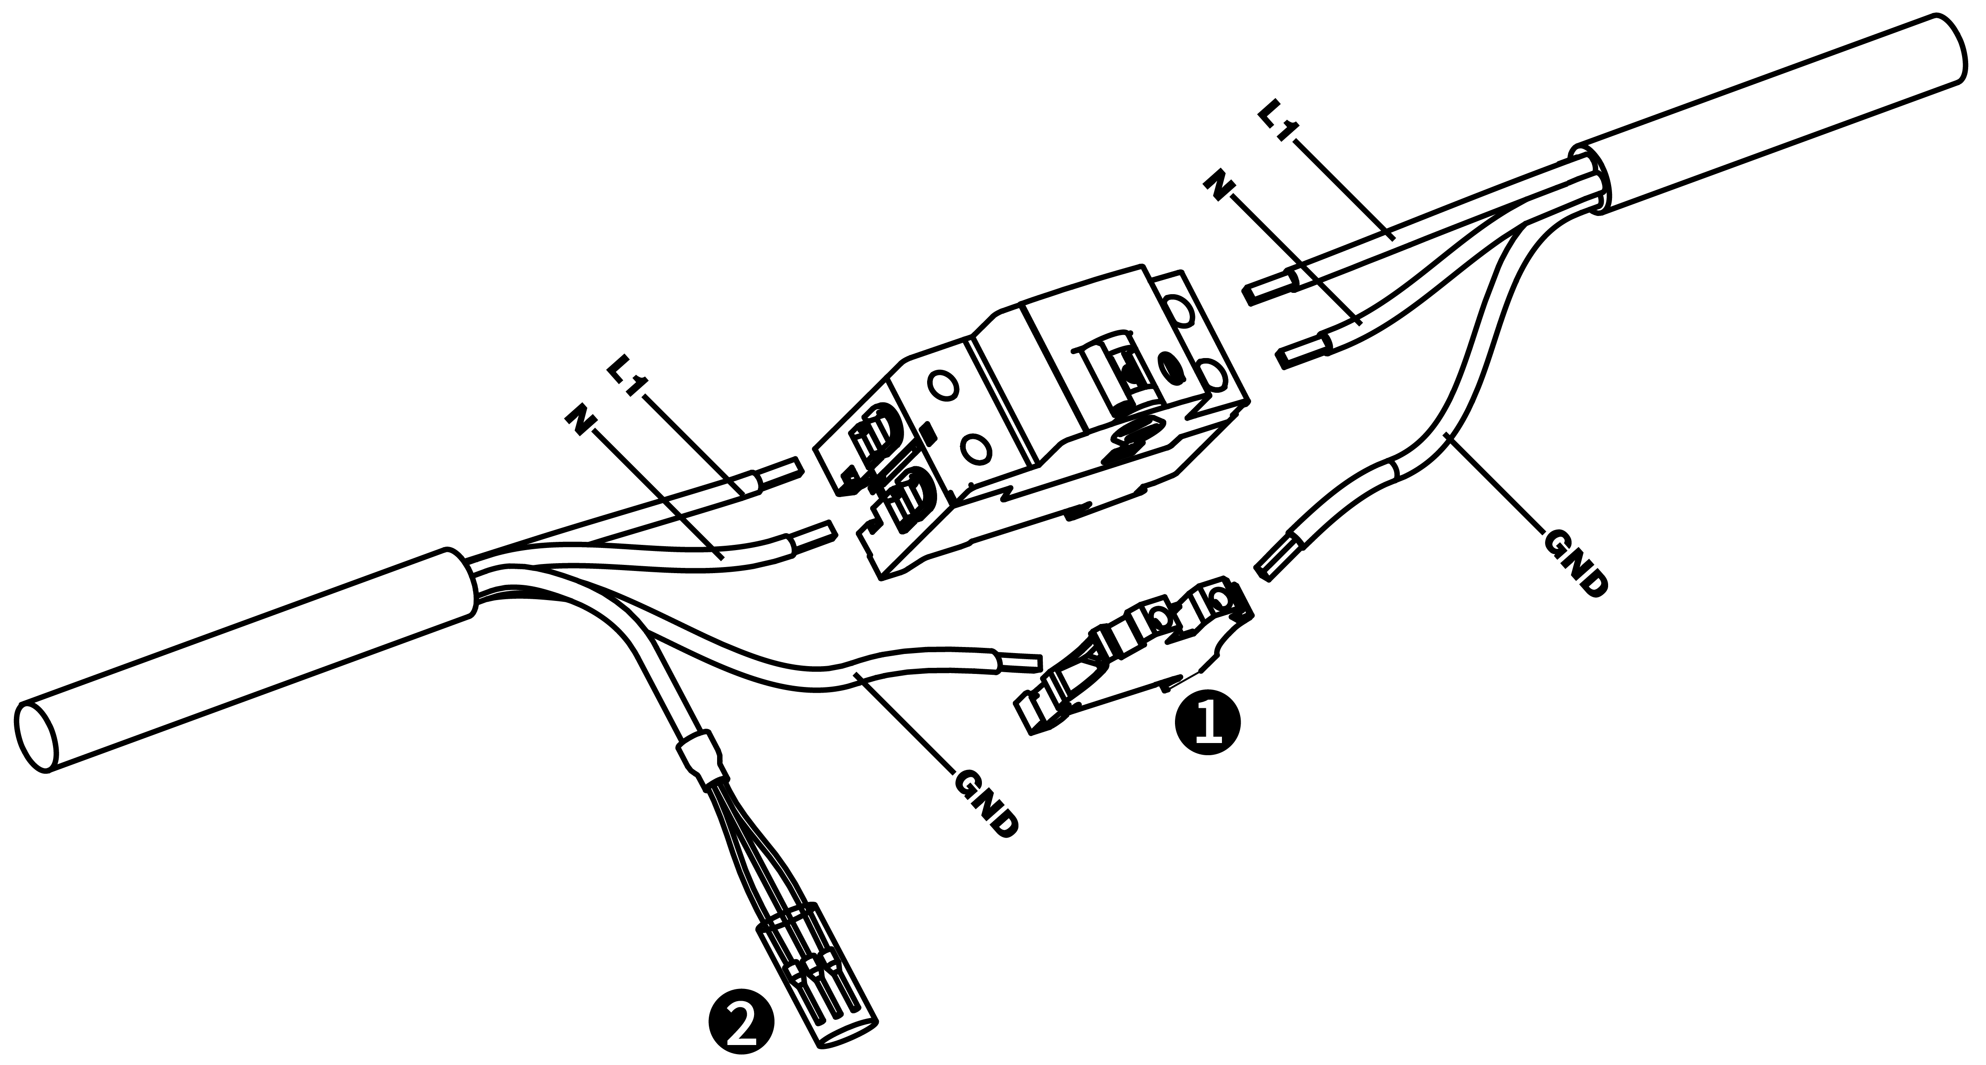

**Distribution Box Wiring for Three-phase:**

**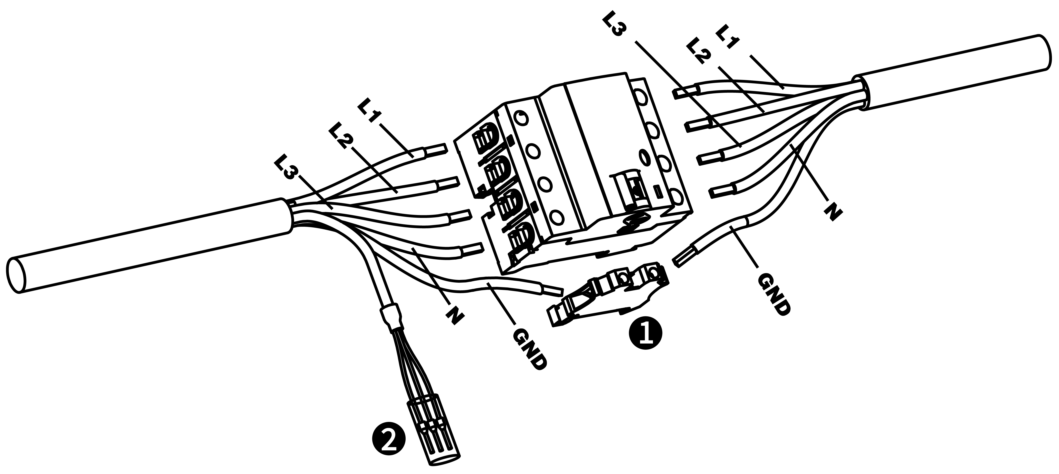**

1. Terminal Block
2. RS485 Communications Cables with Electrical Tape
   1. Protective Device

|  |  |
| --- | --- |
| **Devices** | **Specifications** |
| Dedicated upstream protection device(s) | Options:   * RCD (Type A minimum) + MCB * RCBO (Type A minimum) |
| Upstream overcurrent protection breaker, such as RCBO or MCB  (The breaker serves as the main disconnect switch to the charger.) | Breaker rating:   * 40 A for a 32 A rated charger * 20 A for a 16 A rated charger   Tripping characteristics: type C |
| Upstream residual-current device (RCD) | Minimum Type A, with a rated residual operation current of maximum 30 mA  (Internal to charger is DC fault current monitoring > 6 mA.) |

**NOTE**

The breaker value depends on the diameter and length of the cable, charger rating, and the environmental parameters (for the electrician to decide).

The MaxiCharger AC Wallbox has the internal 30 mA AC and 6 mA DC leakage current detection, which is equivalent to Type B RCD function and meets IEC-61851 standards.

In some countries, local standards may require external protection devices. Check the local standards accordingly. External RCD+MCB or RCBO are also recommended as below:

* 7.4 kW: 30 mA Type A RCBO 230 V/40 A
* 11 KW: 30 mA Type A RCBO 400 V/20 A
* 22 kW: 30 mA Type A RCBO 400 V/40 A

Otherwise, comply with local regulations.

1. Operation
   1. Energize the Charger

Turn on the circuit breaker and wait for the power supply to come on. There will be a series of self-check starts, making sure that the charger works correctly and safely. If a recoverable error is detected, the charging LED illuminates yellow; if the error cannot be recovered, it illuminates red.

**WARNING**

Be careful when working with electricity.

* 1. Start Charging
     1. Cable Models

1. Remove the charging handle from the cradle of the charger.
2. Insert the charging handle into the charging port on the EV.
3. Choose from the following ways to start a charge session:

* Tap the RFID card on the RFID reader.
* Use the Autel Charge app by tapping **Start** on the Charge screen.
* If a charging schedule is set in the Autel Charge app, the charger will initiate a charge session automatically as scheduled. (Scheduled charging case.)
* If the Plug-and-charge function is enabled in the Autel Charge app, the charger will automatically start charging once the charging handle is properly connected. (Plug-and-charge case.)
  + 1. Socket/Shutter Models

1. Insert the charging handle into the charging port on the EV and the charger socket outlet.
2. Choose from the following ways to start a charge session:

* Tap the RFID card on the RFID reader.
* Use the Autel Charge app by tapping **Start** on the Charge screen.
* If a charging schedule is set in the Autel Charge app, the charger will initiate a charge session automatically as scheduled. (Scheduled charging case.)
* If the Plug-and-charge function is enabled in the Autel Charge app, the charger will automatically start charging once the charging handle is properly connected. (Plug-and-charge case.)

**NOTE**

Ensure your EV is charging. The charging LED on the charger should be flashing green. If you suspect the vehicle is not charging properly, try reconnecting the charge cable or contact the local dealer for support.

* 1. Stop Charging

**NOTE**

* If you disconnect the EV charge cable during the charge session, the charger automatically disconnects the power supply. This stops all charging operations.
* When your vehicle is fully charged, the charger will automatically disconnect the power supply.
  + 1. Cable Models

1. To stop charging, choose either of the following two ways:

* Wait for the charge session to end and no further actions are required in the case of scheduled charging or plug-and-charge.
* The charging LED will light solid green.
* The Autel Charge app displays that the EV is fully charged.
* If the charger has a display, it will show that the EV is fully charged.
* End the charge session by tapping the RFID card on the RFID reader again or via the Autel Charge app by tapping **Stop** on the Charge screen.

1. Remove the charging handle from the EV’s charging port and return it to the cradle of the charger.
   * 1. Socket/Shutter Models
2. To stop charging, choose either of the following two ways:

* Wait for the charge session to end and no further actions are required in the case of scheduled charging or plug-and-charge.
* The charging LED will light solid green.
* The Autel Charge app displays that the EV is fully charged.
* If the charger has a display, it will show that the EV is fully charged.
* End the charge session by tapping the RFID card on the RFID reader again or via the Autel Charge app by tapping **Stop** on the Charge screen.

1. Remove the charging handle from the charger socket outlet and the EV charging port.

**NOTE**

For detailed instructions on how to use the Autel Charge app, please contact your sales representative for relevant documents.

1. Troubleshooting and Service
   1. Troubleshooting Table

|  |  |  |
| --- | --- | --- |
| **Item** | **Problems** | **Solutions** |
| 1 | If the 485 communications cables are not needed to the distribution box. | Use the electrical tape to coil the 485 communications cables respectively. |
| 2 | The charger is successfully bound, but the Bluetooth connection fails. | Check whether the QR code on the charger is consistent with the QR code on the Quick Reference Guide. If so, make sure the Bluetooth is enabled on your mobile device; if not, contact customer support. |
| 3 | The charge session does not start as scheduled. | The EV charge cable cannot be inserted into the EV charge port when scheduling the charge for the first time. Insert the EV charge cable after the schedule is set up. |
| 4 | The charge card is lost. | Go to *Me > My Charger > Charge Card* to delete your card to avoid fraudulent use. Five charge cards can be bound to your account at most. |
| 5 | Over-voltage | Use the multimeter to check whether the voltage on the power input is too high. If the result is greater than or equal to 115 % of the rated voltage (263 V), contact local power grid company. |
| 6 | Under-voltage | Use the multimeter to check whether the voltage on the power input is not sufficient. If the result is less than or equal to 70 % of the rated voltage (161 V), contact local power grid company. |
| 7 | Missing phase | Check the wires in the distribution box. If two wires are connected together accidentally, separate the wires. |
| 8 | Inputs incorrectly wired: possibly Line and Neutral are inverted | Correct the wiring. |
| 9 | Ground fault | Make sure the charger is earthed correctly. |
| 10 | Power failure | Make sure the switch to the circuit breaker is on. |
| 11 | Over-heating | * Check whether the EV charge cable is securely connected. * Ensure the operating temperature is within the specified range on the product label. * Stop charging. Restart charging in half an hour. |
|  |  |  |
| **Item** | **Problems** | **Solutions** |
| 12 | Residual current detected | Unplug the vehicle and plug in again. If the problem persists, contact your local representative. |
| 13 | Abnormal pilot voltage | Unplug the vehicle and plug in again. |
| 14 | Contactor fault | Contact your local representative. |
| 15 | Over current | Unplug the vehicle and plug it again. |
| 16 | Pilot fault | Use an Autel diagnostics tool to scan fault, and contact the vehicle manufacturer to clear fault. |
| 17 | No Proximity Pilot (PP) connection or PP fault | * Examine the connection of the EV charge cable. * Ensure both EV charge cables are not broken or frayed. * If the problem persists, contact your local representative. |
| 18 | E-lock failure | * Examine the connection of the EV charge cable. * If the problem persists, contact your local representative. |
| 19 | Power relay fault | Contact a qualified electrician. |
| 20 | Bluetooth module communication failure | * Make sure the Bluetooth is enabled on your mobile device and the charger is powered on and operating properly. * Forget the charger in the Bluetooth settings on your mobile device and pair the charger to your device via Bluetooth again. * If the problem persists, contact your local representative. |
| 21 | Update failure via Bluetooth | * Make sure the charger is in idle status. * Make sure the Bluetooth connection is working properly. * If the problem persists, contact your local representative. |
| 22 | Internet connection fails | * You may use another device to connect to the same Internet, checking whether the Internet connection is working properly. * If the problem persists, contact your local representative. |
| 23 | Home power system only supports single-phase. How to connect the power supply wiring? | Connect the L1, N, and PE wires to the charger’s terminal block as specified. Wiring to the distribution box is the same. |

* 1. Service

If you cannot find solutions to your problems with the aid from the table above, please contact our technical support.

**AUTEL Europe**

* **Website:** <www.autelenergy.eu>
* **Phone:** +49 (0) 89 540299608 (Monday-Friday, 9:00AM-6:00PM Berlin Time)
* **Email:** evsales.eu@autel.com; evsupport.eu@autel.com
* **Address***:* Landsberger Str. 408, 4. OG, 81241 Munich, Germany

1. Specifications
   1. General Specifications

|  |  |
| --- | --- |
| **Item** | **Description** |
| **Product Information** | |
| Charging Type | Mode 3 charging |
| Input/Output Power Rating and Current | * Single-phase: 7.4 kW/32 A * Three-phase: 11 kW/16 A * Three-phase: 22 kW/32 A |
| Protection | Over-current, over-temperature, over-voltage, under-voltage, ground fault including DC residual current protection, integrated surge protection |
| Earth (Ground) Fault  Protection | 30 mA AC and 6 mA DC |
| Input/Output Voltage | * 230 V ± 15%, single-phase * 400 V ± 15%, three-phase * 50 Hz |
| Network Type | TT, TN |
| **General Characteristics** | |
| IP and IK Rating | * Cable model: IP65, IK08 * Socket/shutter model: IP54, IK08 |
| Operating Altitude | 2,000 m |
| Humidity | < 95 % RH, non-condensing |
| Operating Temperature Range | -40 °C to + 55 °C |
| Storage Temperature Range | -40 °C to + 85 °C |
| Mounting | Wall or floor using a pedestal |
| Dimensions  (H × W × D) | * Cable: 336 x 187 x 85 mm * Socket/shutter: 336 × 187 × 115 mm |
|  |  |
|  |  |
| **Item** | **Description** |
| Weight | * Cable (5 m) model: 7.4 kW/11 kW: 4.7 kg ; 22 kW: 6.2 kg * Cable (5 m) + LCD model: 6.45 kg * Socket model: 7.4 kW: 3.3 kg ; 22 kW: 3.4 kg * Socket + LCD model: 4.2 kg * Shutter model: 7.4 kW: 3 kg ; 22 kW: 3.1 kg |
| **User Interface** | |
| Status Indication | * LED * App |
| User Interface | Autel Charge app |
| Connectivity | * 4G * Bluetooth * Wi-Fi * Ethernet |
| Communications Protocols | OCPP 1.6J |
| User Authentication | * App * RFID card * QR code |
| **Software Update** | |
| Software Update | * OCPP 1.6J * App * Web portal |
| **Certifications and Standards** | |
| Safety Standards | IEC/EN 61851-1, EN 62311, EN 62479, IEC/EN 62955 |
| Certifications | * CE * TUV * TR 25:2016 (ICS 43.120) |
| Warranty | 36 months |

* 1. Cable Specifications

|  |  |  |
| --- | --- | --- |
|  | Parameter | Specification |
| AC Input Cable (Three-phase, 32 A) | Wire size | Cross-section: 5 x 6 mm2 |
| Length | 1800 mm |
| Strip length | 12 mm |
| Outside diameter | 17.8 mm |
| AC Input Cable (Three-phase, 16 A) | Wire size | Cross-section: 5 x 2.5 mm2 |
| Length | 1800 mm |
| Strip length | 12 mm |
| Outside diameter | 14.6 mm |
| AC Input Cable (Single-phase, 32 A) | Wire size | Cross-section: 3 x 6 mm2 |
| Length | 1800 mm |
| Strip length | 12 mm |
| Outside diameter | 14.6 mm |
| RS485 cable | Wire size | Cross-section: 3 x 0.5 mm2 |

* 1. Supplementary Specifications

|  | **Item** | **Description** |
| --- | --- | --- |
| **MCB+RCD** | Power Rating | * Single-phase: 7.4 kW, 30 mA * Three-phase: 11/22 kW, 32 mA |
| Protection | Over-current, over-voltage, under-voltage, over-temperature, ground fault including DC residual current protection, and integrated surge protection |
| Voltage | * Single-phase: 230 V AC * Three-phase: 400 V AC |
| Single-phase Type | * MCB: GSB2-63M/2 C50 * RCD: VIGI-63/2 30 mA, DC 6 mA |
| Three-phase Type | * MCB: GSB2-63M/4 C50 * RCD: VIGI-63/4 30 mA, DC 6 mA |
| **Module Cover Surface** | Power Rating | * Single-phase: 7.4 kW * Three-phase: 11/22 kW |
| **Emergency Stop** | Specification | Available for 7.4 kW, 11 kW, and 22 kW models. |

* 1. Manufacturer and Models

|  |  |  |
| --- | --- | --- |
| **Item** | **Manufacturer** | **Model** |
| Emergency stop | Schneider Electric Industries SAS | XALK178  Type : DC 12 |
| Distribution box for  11/22 kW model | Ensto Finland Oy | MODAB81PN  (Size : 238x231x113 mm) |
| Distribution box for  7.4 kW model | Ensto Finland Oy | MODAB41PN  (Size : 166x231x113 mm) |
| Circuit breaker for  11/22kW model | Tianshui 213 Electrical Apparatus Co., LTD. | GSB2-63M/4 C50 |
| Circuit breaker for  7.4 kW model | Tianshui 213 Electrical Apparatus Co., LTD. | GSB2-63M/2 C50 |
| RCD for 11/22 kW model | Tianshui 213 Electrical Apparatus Co., LTD. | VIGI-63/4 30 mA, DC 6 mA |
| RCD for 7.4 kW model | Tianshui 213 Electrical Apparatus Co., LTD. | VIGI-63/2 30 mA, DC 6 mA |

**NOTE**

Typically, the 6 mm2 insulated electrical wire is used. If it contradicts with your local rules, refer to your local rules.

* 1. Product Dimensions
     1. 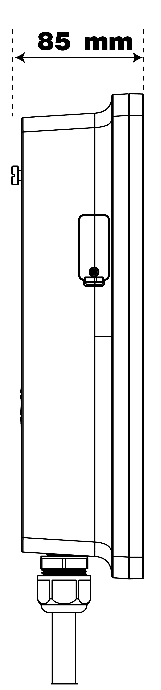Cable Model

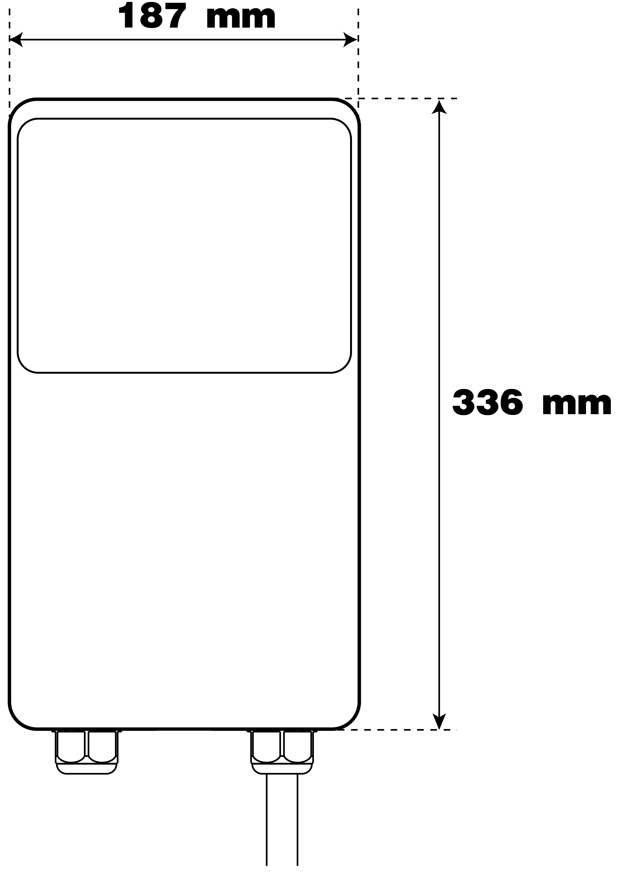

* + 1. Socket/Shutter Model

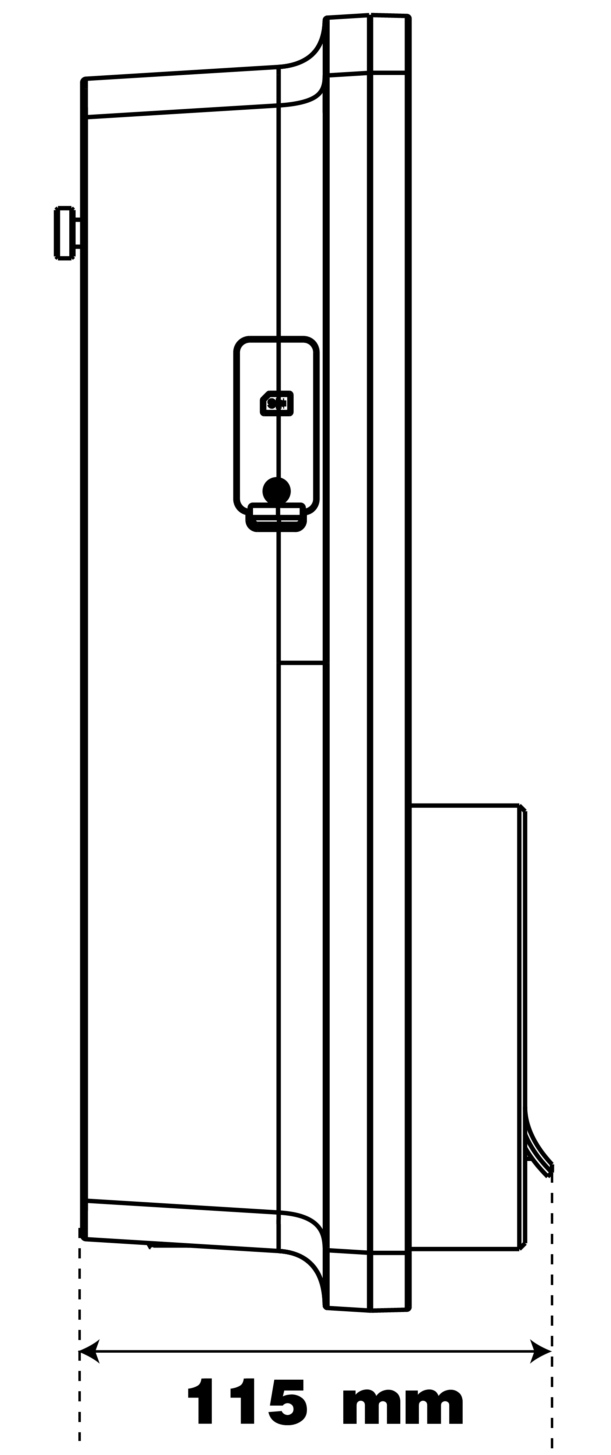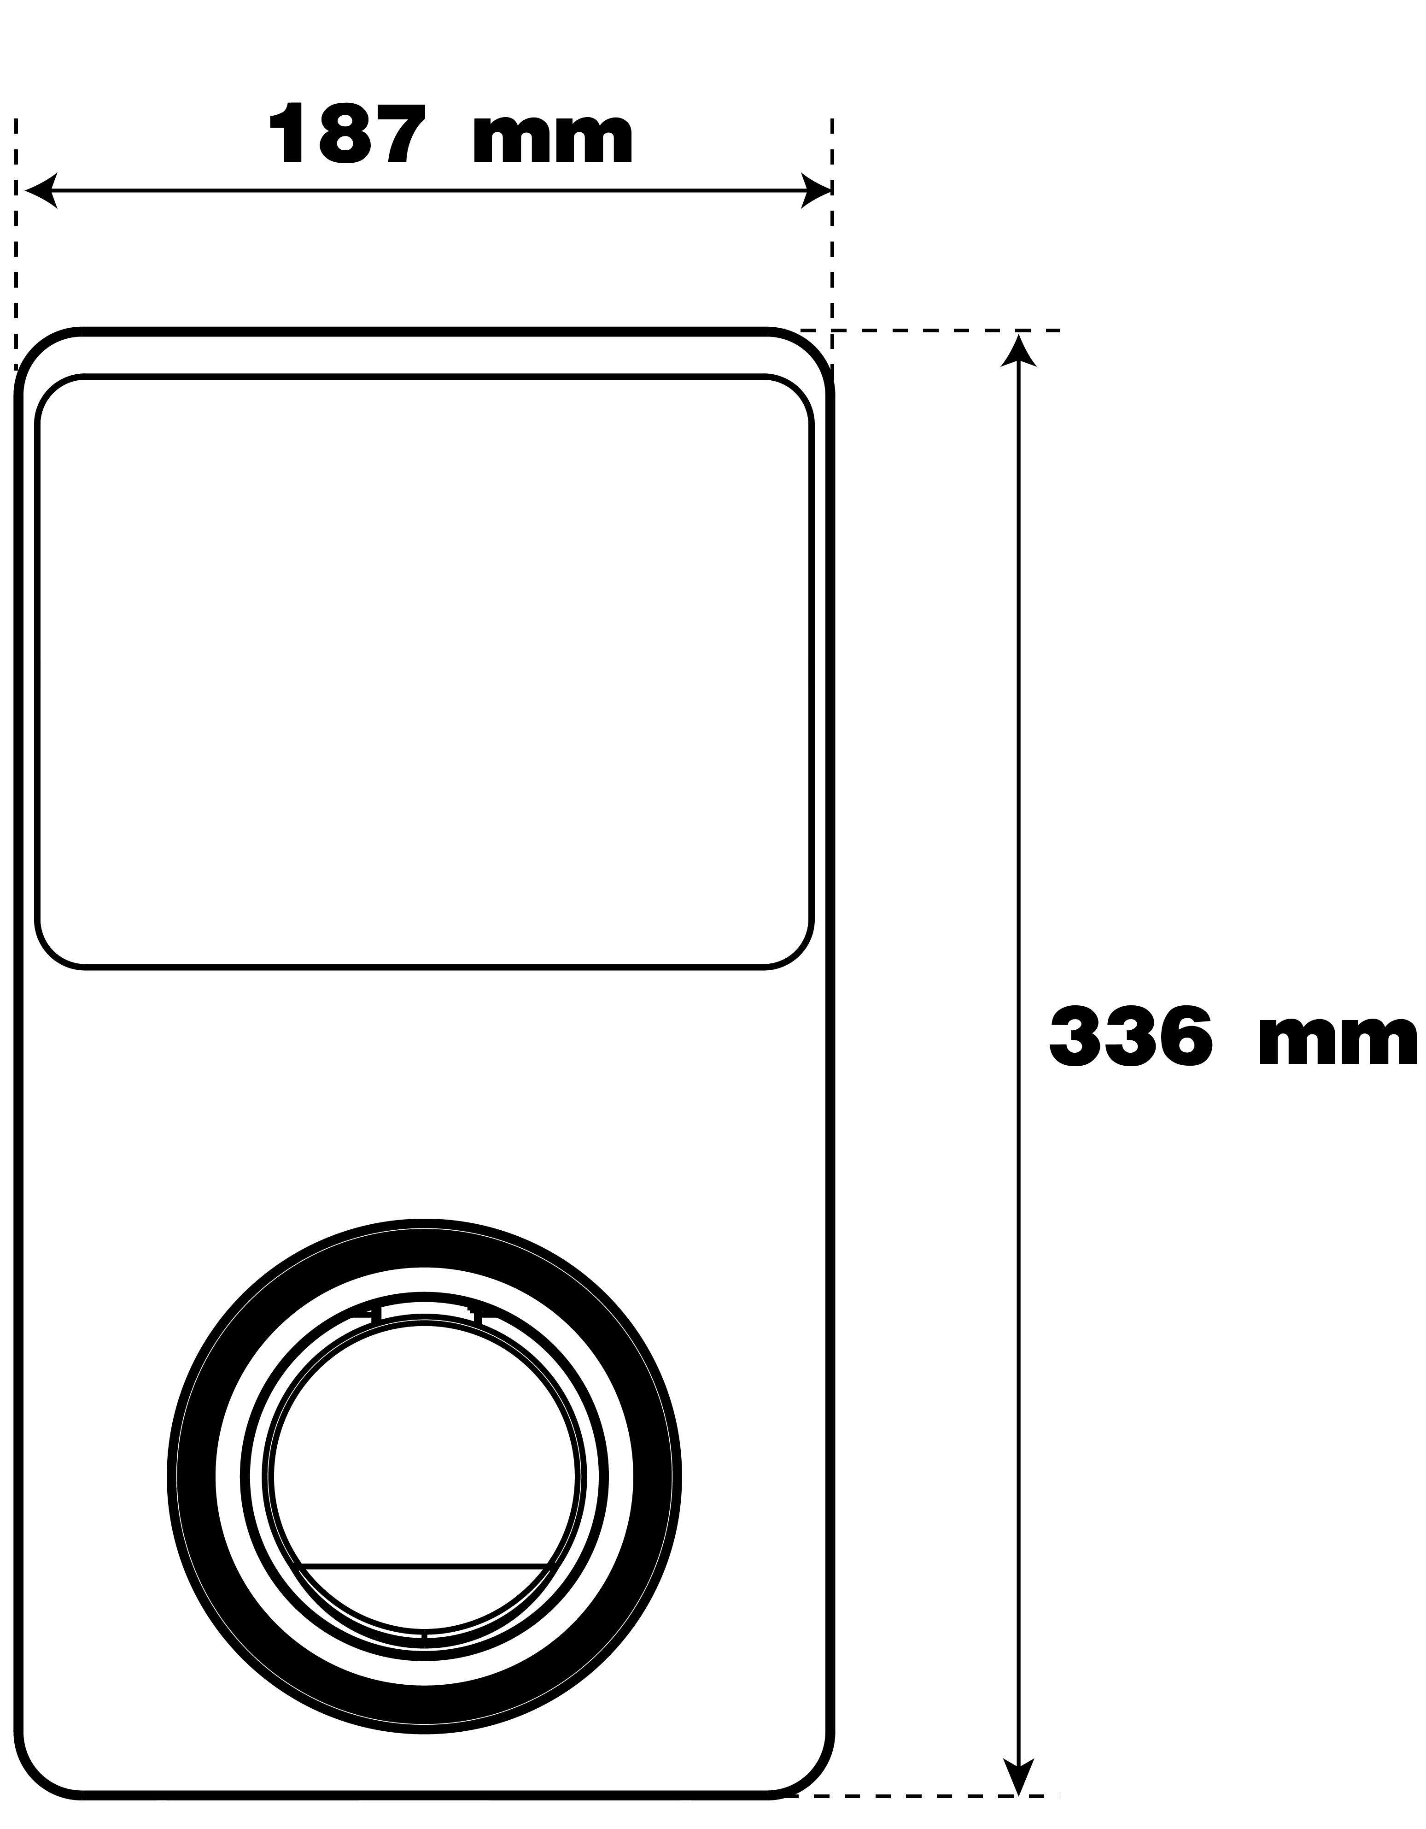

1. Compliance Information

The product is in conformity with the following standards and/or other normative documents:

EN 301 489-1 V2.2.3

EN 301 489-3 V2.1.1

EN 301 489-17 V3.2.4

EN 301 489-52 V2.1.1

EN 300 328 V2.2.2

EN 300 330 V2.1.1

EN 301 908-1 V13.1.1

EN 301 908-2 V13.1.1

EN 301 908 -13 V13.1.1

EN 301 511 V12.5.1

EN 50663

EN 50665

BS EN IEC 61851-1

EN IEC 61851-1

IEC 61851-21-2

EN IEC 61851-21-2

EN 50470-1

EN 50470-3

TR 25:2016 (ICS 43.120)

1. Appendix
   1. Fault Codes List

The table below contains the fault codes on the Autel Charge Cloud and their descriptions on the Autel Charge app or the charger’s display.

|  |  |
| --- | --- |
| **Fault Codes** | **Descriptions** |
| 0 | Mains overvoltage |
| 1 | Mains undervoltage |
| 2 | Mains over-frequency |
| 3 | Mains under-frequency |
| 4 | Phase loss |
| 5 | Line/Neutral reverse connection |
| 6 | Ground fault |
| 7 | Abnormal shutdown |
| 8 | Over-temperature |
| 9 | Leakage current |
| 10 | CP voltage abnormal/grounded |
| 11 | Contactor abnormal |
| 12 | Output overcurrent |
| 13 | Vehicle S2 failure |
| 14 | Vehicle CP negative failure |
| 15 | PP signal disconnected |
| 16 | PP signal abnormal |
| 17 | Electronic lock fault |
| 18 | PME fault |
| 19 | PME failed to disconnect relay |
| 20 | COMM error with control board |
| 21 | Electric meter abnormal |
| 22 | Data error |
| 23 | Leakage current (AC) |
| 24 | Trip fault |
| 25 | Sensor self-test fault |
| 26 | Output ground fault |
| 27 | Ground self-test fault |
| 28 | Microelectronics fault |



**www.autelenergy.com**